

**Project Report**

Course title: Software Project III

Course code: CSE316

**Submitted To:**

Fahim Faisal

Lecturer

Department of Computer Science and Engineering

Daffodil International University

**Submitted by:**

Tanha Tul Tasnim

ID:221-15-5626

Section:61_V

Department of Computer Science and Engineering

Daffodil International University

Table of Contents

1. Introduction 3

1.1 What is a Coffee Shop Website 3

1.2 Purpose 3

2. Key Feature of Coffee Shop Website 3

3. Requirement 3

3.1 Functional Requirements 3

3.2 Non-Functional Requirements 4

3.3 System Design 4

4. Architecture Design 4

4.1 Technical Documentation 5

4.2 System Architecture 5

4.3 Development Tools 5

4.4 System Implementation 5

4.5 Design Requirements 6

4.6 Testing implementation 6

4.7 Framework 6

4.8 Model 7

5. Website Design Work View 7

5.1 Web Front Page 7

5.2 Website Prototype Image 7

6. Benefits of Coffee Shop Website 9

7. Challenges of Coffee Shop Website 9

8. Scalability and Flexibility 9

8.1 Integration Capabilities 10

8.2 User-Friendly Interface 10

9. Conclusion 10

9.1 Code git-hub Link : 10

9.2 Prototype Link : 10

“A Coffee Shop Website”

# 1. Introduction

## 1.1 [What is a Coffee Shop Website](https://qualcampus.com/what-is-a-campus-management-system-cms/#one)

The "A Coffee Shop Website" project aims to create an attractive and user-friendly online presence for local coffee shop. This website serves as a digital extension of the coffee shop, providing visitors with essential information about the shop, its menu, and its services. Creating this appealing and functional website, the coffee shop can attract more customers, provide better service, and establish a stronger brand identity.

## 1.2 Purpose

The primary objective of this project is to design and develop a user-friendly website for a coffee shop that enhances customer engagement, provides essential information, and promotes the shop's products and services. It can even act as an online store for beans and merchandise, all while providing educational and entertaining content to get customers engaged with us.

# 2. Key Feature of Coffee Shop Website

* Home Page : An inviting landing page with an overview of the coffee shop.
* About : A section that shares the story, values, and mission of the coffee shop.
* Category & services : Detailed information about the beverages and food items offered.
* Location and Contact: Information on how to find the shop, including an interactive map and contact details.
* Blog &News: Updates about new products, events, and promotions.
* Customer Reviews: A section for customer feedback and testimonials.
* Social Media Links: Integration with social media platforms.

# 3. Requirement

## 3.1 Functional Requirements

* Hardware
  + A computer with internet access.
* Software
  + A text editor (such as VS Code or Sublime Text), web browsers (Chrome, Firefox), and an image editor (such as Photoshop or GIMP).
* Technical Skills
  + - -Knowledge of HTML, CSS, and basic web design principles.
* Usability
  + - -User-friendly interface.
    - -Accessible to users with disabilities.
* Resource Allocation
  + - -Manage resources ( equipment).
    - -Schedule and allocate resources for order and events.

## 3.2 Non-Functional Requirements

* Performance

-Fast response time.

-Efficient data retrieval and processing.

* Security

-Secure user authentication and authorization.

-Data encryption and protection against breaches.

* Scalability

-Ability to handle increasing number of users and data.

-Maintainability

-Easy to update and maintain.

## 3.3 System Design

* Conceptual Model

-Use Case Diagrams

-Diagrams illustrating interactions between users and the system.

* Entity-Relationship Diagrams (ERD)

-Diagram shows the relationships between entities in the database.

* User Interface Design

-design and implementation system interfaces ensuring usability and accessibility.

-Database schema normalized to third normal form (3NF) to eliminate redundancy.

# 4. Architecture Design

The architecture of the website will follow a client-server model. The client-side will be built using HTML and CSS, ensuring a responsive and visually appealing interface. The server-side could potentially be expanded in future iterations to include dynamic content using technologies such as JavaScript, Python, or a CMS like WordPress.

## 4.1 Technical Documentation

* System architecture documents.
* Database schema and ER diagrams.
* Documentation.

## 4.2 System Architecture

* Client-server architecture.
* Web-based application.

## 4.3 Development Tools

* Text Editor: VS Code
* Web Browsers: Google Chrome, Mozilla Firefox
* Version Control: Git and GitHub
* Design Tools: Adobe Photoshop, GIMP
* Testing Tools: Browser developer tools

## 4.4 System Implementation

* Development

-Development of CMS based on design specifications.

-Use of modular approach for ease of maintenance and scalability.

* Tools and Languages

-Frontend: React.js for dynamic UI.

-Backend: Node.js and Express.js for server-side logic.

-Database: PostgreSQL for data management.

* Testing and Quality Assurance

-Test cases for each functional requirement.

-Scenarios for edge cases and performance testing.

* Testing Methods

-Unit Testing: Testing individual components.

-Integration Testing: Testing interactions between components.

-System Testing: End-to-end testing of the entire system.

-Usability Testing: Gathering feedback from actual users to improve the UI/UX.

## 4.5 Design Requirements

In this process we used many elements to build my project. Here some of the elements given below

-HTML: to design font-end layout.

-CSS: CSS called a cascading style sheet. CSS3 to design the project.

-Bootstrap: to made this website responsive using Bootstrap

-JavaScript: I will use JavaScript to make our site more attractive.

-Pixie: It is used to get color codes.

-Photoshop: It is used to make a logo, banner and get exact measurement to design this project.

-XAMPP 7.4: use the XAMPP server as my local server to develop my project.

## 4.6 Testing implementation

There are many important efforts need to build a web application better. Among them, testing is one of the important parts of web design and development. Before releasing a web application to the user it’s the final step. The drawbacks and errors of a web application come in front of developer due to testing process. After the testing developer can think of the next step. So testing is very essential in the field of web engineering.

-Error testing: test lots of input to find whether there was an error had or not. Whenever find an error, solved it and made sure that it never could happen again.

-Data validation: Data validation is a very essential part of the web applications. Because security is the main prospect of any application. testing data validation by giving some valid and invalid input data and check the desired result.

- Unlimited data store: Unlimited data can reduce systems speed. It increases unwanted loading time. Which makes the application heard and uncomfortable to use.

## 4.7 Framework

For this project, a lightweight CSS framework like Bootstrap will be used to ensure responsive design and ease of development.

## 4.8 Model

The website will follow a single-page application (SPA) model for simplicity and improved user experience. Each section of the website will be contained within one HTML file, and navigation will be handled through anchor links.

# 5. Website Design Work View

## 5.1 Web Front Page

## 5.2 Website Prototype Image

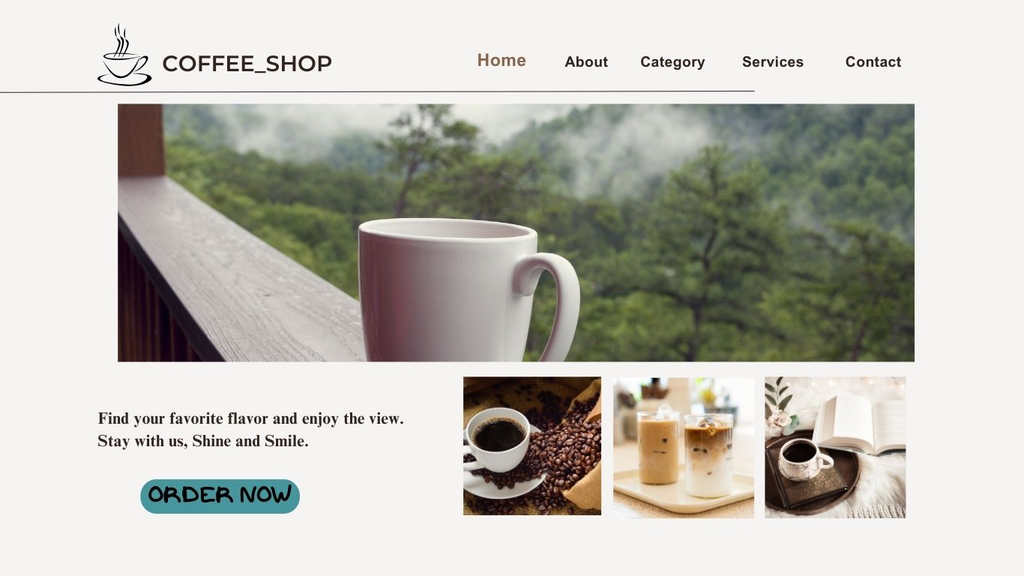

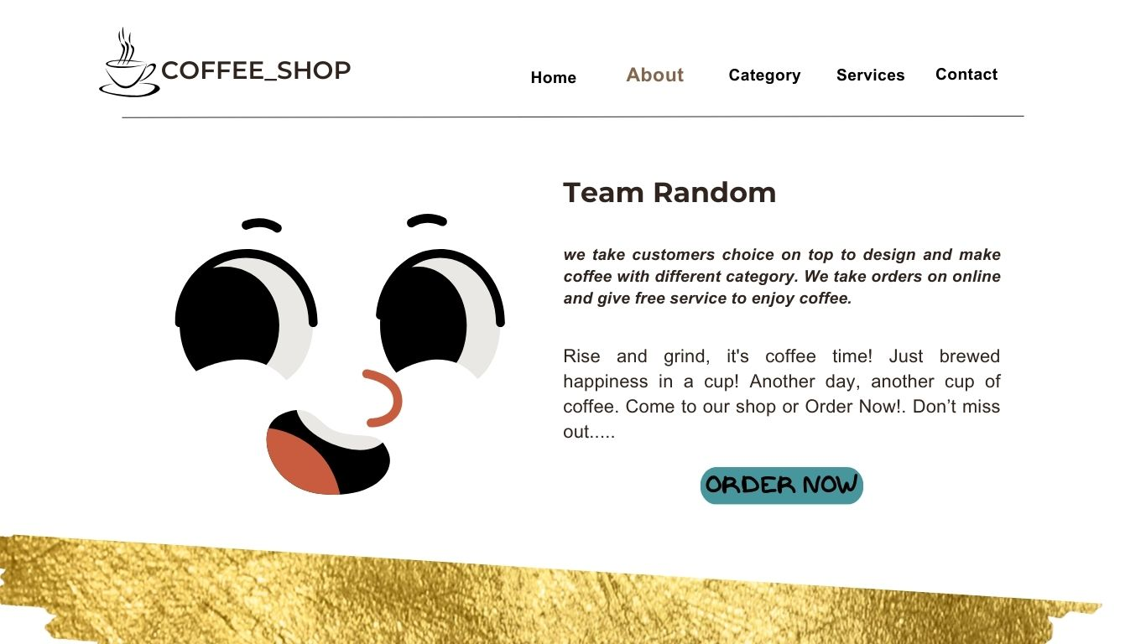

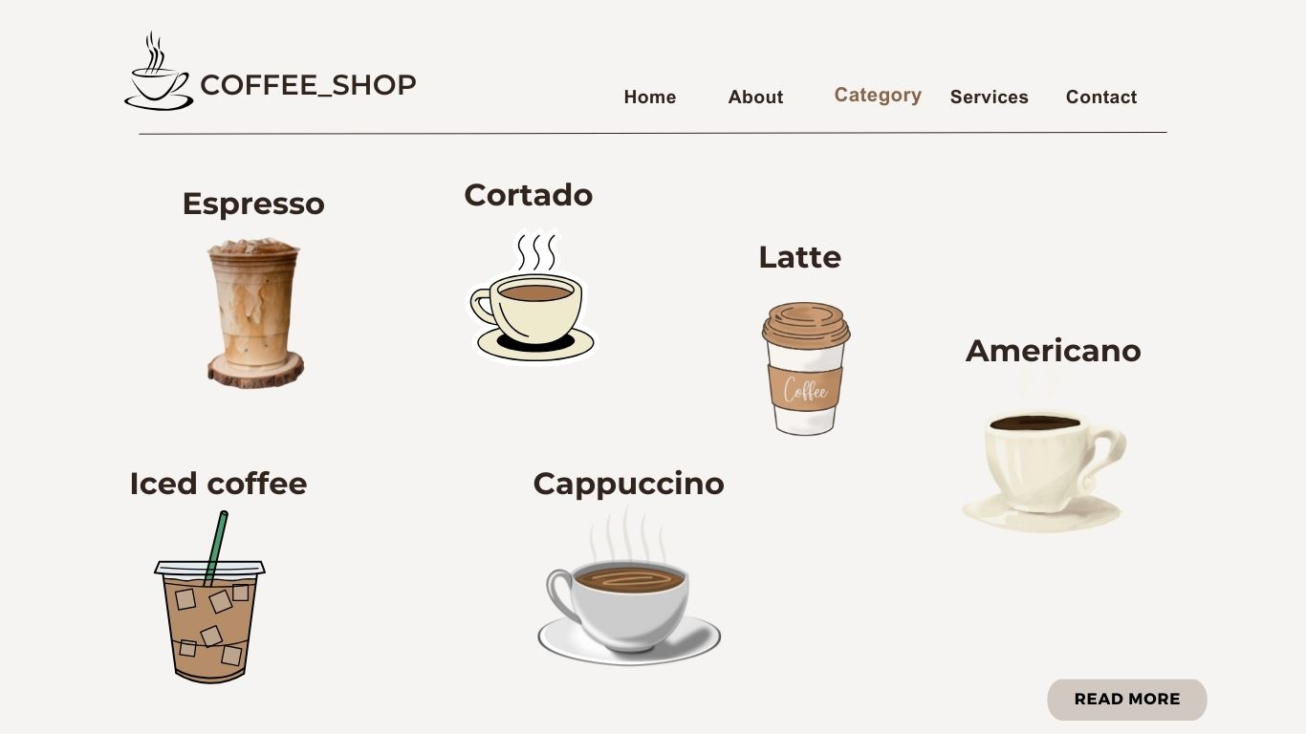

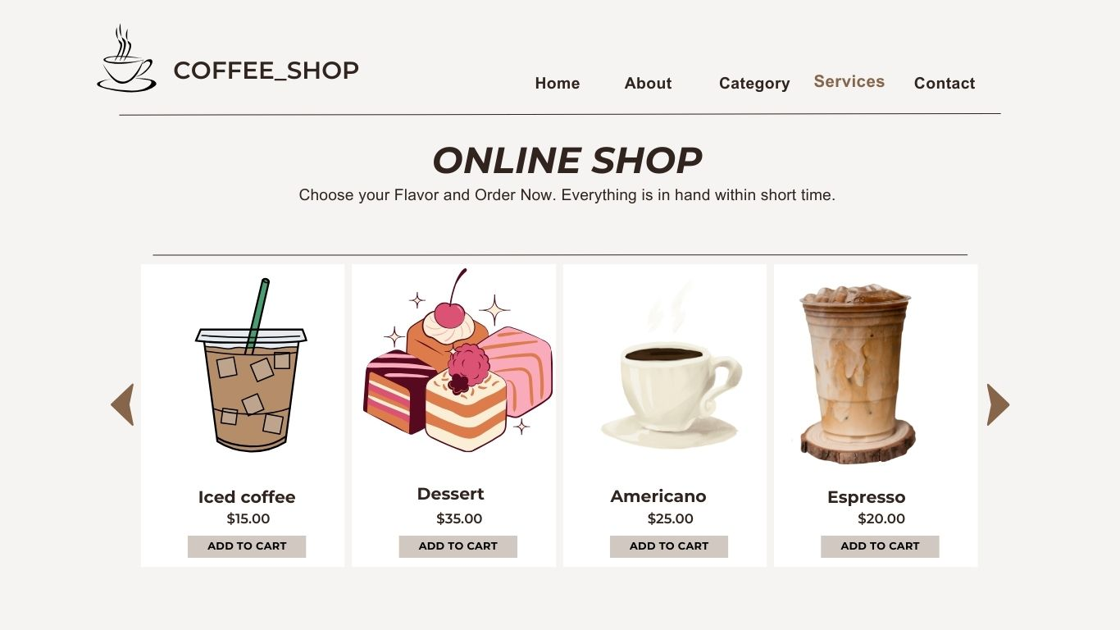

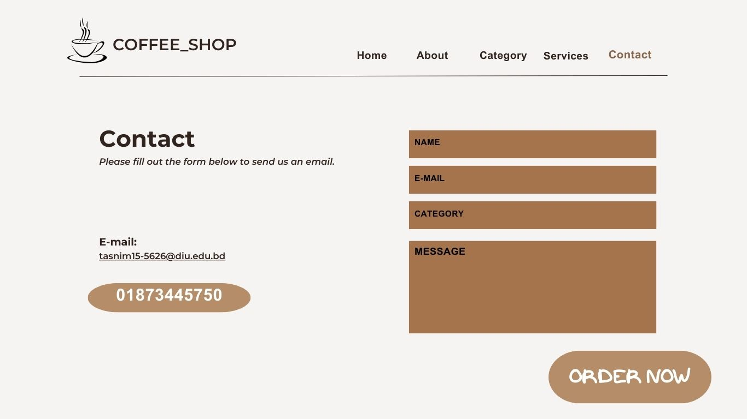

# 6. Benefits of Coffee Shop Website

* Easy, fast and comfortable
* Increased customer loyalty
* Safer and healthier
* Highly customizable and less chance for errors
* Staffing cost is reduced
* Customer don’t have to wait in line to order
* Increase repeat visits and increase order sizes.
* Provides information readily available to customers at any time.
* Acts as a platform for promoting new products and events.

# 7. Challenges of Coffee Shop Website

* Data security
* Risk of losing customers' data
* Chances of a technical problem in the system
* Mismatch data of orders, customers and drivers
* Keeping the website content current and relevant.
* Ensuring the website ranks well on search engines.
* Difficulty in choosing the right developer to develop a customized system

# **8. Scalability and Flexibility**

The website is designed to be scalable and flexible. Future enhancements could include an e-commerce feature, user accounts, or a loyalty program. The use of a CSS framework like Bootstrap ensures that the design can be easily adjusted to accommodate new features.

## ****8.1 Integration Capabilities****

The website will be designed with the capability to integrate with various third-party services, such as Google Maps for location, social media platforms for engagement, and email marketing tools for customer communication**.**

## ****8.2** User-Friendly Interface**

Accessibility and user experience play a pivotal role in the successful implementation of any webpage. Ensure that the page you choose is user-friendly and that adequate training and support are available. The interface will be clean and simple, with intuitive navigation and accessible information. The use of Bootstrap ensures that the website is responsive, providing a consistent user experience across all devices.

# **9. Conclusion**

The Coffee Shop Website project aims to create an engaging, informative, and user-friendly online platform that enhances the coffee shop’s digital presence. By focusing on responsive design, high-quality content, and an intuitive user interface, the website will serve as a vital tool for attracting and retaining customers. Despite potential challenges, the benefits of increased visibility, improved customer experience, and effective brand building make this project a valuable investment for the coffee shop's future growth and success.

## 9.1 Code git-hub Link :

<https://github.com/Tttasnim?tab=repositories>

## 9.2 Prototype Link :

<https://www.canva.com/design/DAGFWZbGG84/rVJfOFN1yCWpHElxVOfPdQ/edit?utm_content=DAGFWZbGG84&utm_campaign=designshare&utm_medium=link2&utm_source=sharebutton>